RBF - PROJECT: evaluating RESULTS 2021

Lacor and Kalongo Hospitals –Uganda

**"Result Based Financing, a change engine for paediatric services"**

Intervention to strengthen the quality of care and empowerment of health personnel in the Acholi region, Northern Uganda. Implemented in the Acholi Region: Districts of Gulu, Amuru and Agago (Northern Uganda) Based in Gulu (Lacor H) and Kalongo (Kalongo H)

E. Ochola, M. Ogwang, V. Omona, Smart G., Squillaci T, Orlotti C., D’Agostino, Suardi, Ambrosoli, Colvin ecc

Prof. Luigi Greco, University of Naples Federico II, Quality Officer , Carmela Arcidiaco, data manager.

**SUMMARY**

1. **Objective of the project**
2. **Study design**
3. **Section 1: Analysis of the quarterly quality assessment forms**
   1. **Objectives**
   2. **Methods**
   3. **Results**
      1. Quality scores for each domain
      2. Improvements on the quality scores
      3. Quality scores for specific items
   4. **Conclusions**
   5. **Suggestions**
4. **Section 2: Quality assessment scores for Clinical Management**
   1. **Objectives**
   2. **Methods**
   3. **Results**
      1. Final diagnosis in the two hospitals
      2. Clinical Management at Kalongo
         1. Distribution of Clinical Management Scores I 2016 and 2020
         2. Percent of the maximum score achieved in 2016 and 2020
         3. Multivariate analysis
      3. Clinical Management at Lacor
         1. Distribution of Clinical Management Scores I 2016 and 2020
         2. Percent of the maximum score achieved in 2016 and 2020
         3. Multivariate analysis
   4. **Preliminary observations**
   5. **Critical points**
   6. **Achieved results**
   7. **Suggestions**
5. **Non communicable diseases**
6. **Neonates at Lacor Hospital**
7. **OBJECTIVE OF THE PROJECT**

To evaluate the impact of Result Based Financing project in Northern Uganda on process and health indicators in the two locations involved in the intervention

1. **STUDY DESIGN**

Prospective observational study.

Process and health indicators in the years prior to the intervention

Process and health indicators at the end of the intervention

Progress of quality scores over time

1. **FIRST SECTION: Analysis of the 3-monthly quality assessment forms at the Children’s ward from 2018 to 2020 (See Annex 1)**
   1. OBJECTIVES

To assess, every three months, the quality of the structures, facilities, provisions and practices in the children’s ward.

* 1. METHODS

At the start of the project a quality assessment form (Annex 1) was developed to estimate the gaps and the actions to encourage improvement in the quality of services offered to sick children. The quality items were shared with the staff of the hospital and, especially, with the staff of the childrens’ ward.

At St. Mary’s Hospital Lacor (Lacor Hospital) and Kalongo Ambrosoli Hospital an external commission visited the Children’s wards every three months (quarter) and scrupulously examined structures, management and procedures within each of these domains to be evaluate and to which assign the relevant numeric scores.

The forms listed each item (for example: *Prevention of Infections*, which included: 1. Facilities to wash hands, 2. Alcohol available 3. Reduce cross contamination among children(beds?) then the evaluation criteria were listed, the max possible score and the critical points.

For each item the commission assigned a score from 0 = no improvement, not done, to 3 = well done, fully functional, available to care. (see Annex 1)

The quality control forms that were filled in during these quarterly verifications were transposed into an Excel spreadsheet and translated for a statistical analysis (SPSS vers. 26).

Note: Time 0 is the status before the start of the RBF project as estimated and reported by the in situ evaluation in Jan 2018.

Time 12: is 12th quarter, the end of the RBF project (Dec. 2020) when the maximum achievable score for each item could have been reached.

Individual items of the forms were grouped into the respective domains, by summing up the scores within each domain:

Str Man, Structure & Management: Items from 1 to 8; max = 24

Hygiene: items from 9 to 18; max = 23

Clinical: Items from 19 to 24; max = 33

Emergency: items from 25 to 26; max = 8

Training: items from 27 to 29; max = 9

The percentage of the maximum score was estimated by: (score observed for the domain *100)/maximum score for that domain.

A Global Score was computed by summing the 5 domains.

Statistical Analysis: The graphs show the trend over time from Time 0 (2018) to quarter 12 (2020).

* 1. **RESULTS**

**3.3.1 Profiles of the quality scores for each domain over time**

Score for each domain over Time, where 0 = starting time 2018 and 12 = End of the project Dec. 2020

* + 1. **Improvement of quality scores for each domain over time**

The improvement of the score for each domain was obtained from the ratio between the observed score and the maximum score possible for the respective domain. Expressed as a percentage.

PRELIMINARY COMMENTS

LACOR: It is clear that, soon after the start of the project, the actions put in place to improve the structure, the management and the procedures at the Children’s ward, allowed a steep rise in the achieved percentage of the maximum score. It should be considered that the starting status at Lacor was already quite acceptable in 2018, so dramatic changes could not be expected. After the first year (Time 3 = 3rd quarter) minimal changes were observed for most items.

The exception was training, where the rotation of medical students and the occasional presence of expatriates did not allow to estimate ad adequate performance in the training domain.

KALONGO: The starting status at Kalongo suffered in 2018 from several gaps, so the scores of each domain improved gradually over the first 5 quarters. The children’s ward was completely re-established in 2018-2019; this allowed a significant catch up in the scores achieved. The erratic presence of a paediatric specialist was related to the several gaps observed in the Clinical Procedures.

As at Lacor the training domain suffered from the absence of supervision and the occasional presence of trainees.

* + 1. **TRENDS OF THE QUALITY CONTROL SCORES FOR EACH DOMAIN**

**Structures** sum of items: Structure, Beds, Rooms, Latrines

**Equipment** sum of items: Equipment, Safety, Dispensers, Stock, Uniform

**Hygiene** sum of items: Hygiene, Infections, Clean, Water, Sterile

**COMMENTS:** The effort to improve structures, equipment and hygiene in both hospitals during the first year (1-3 quarters) of the RBF project was remarkable.

1. **CLINICAL MANAGEMENT** (Items 19 to 24)

Proper diagnosis of 10 admitted cases

Proper prescription of therapy of at least 10 admitted cases

Proper administration of therapies to 10 admitted cases

Deaths properly reviewed

Appropriate supervision and mentorship by Specialists and Head of Department

Nice and caring communication to Patients and attendance

**COMMENTS:**

It is clear that the presence of specialists and residents at Lacor allowed to maintain an acceptable level of performance in all the three items related to clinical diagnosis, prescription of therapies and administration of the prescribed therapies.

The sporadic presence of the specialist in Kalongo is reflected in the performance gaps in the three clinical items.

**HOSPITAL SERVICES:**

Adequate support from the Radiology Department?

Adequate support from the laboratory?

Are the right Drugs available when needed?

**COMMENTS:**

The services at Lacor offer an acceptable level of quality. In Kalongo, only the Laboratory has a stable performance, while the services related to RX and provision of Drugs are erratic.

* 1. **CONCLUSIONS**

The Figures illustrate the scores obtained for each domain in each quarter : summary scores are also computed by aggregating items of the same domain to improve data readability .

Both hospitals showed a steep increase in the scores for all domains in the first year (quarters 0-3).

In Lacor the levels achieved for most domains did not require greater improvement: the graphs show that high scores were kept throughout the project. Lacor hospital staff and management showed a remarkable capacity to keep a stable and sustainable high quality profile over time, suggesting that the RBF project became mostly ordinary routine practice, rather than an occasional effort to improve the service in order to be rewarded.

In Kalongo Hospital the starting facilities suffered from several gaps: hence a longer time, the first 6 quarters, was required to establish a high level of quality of the services.

Graph. 2.3 shows that the improvement from start to end of the project was considerably higher in Kalongo than in Lacor, due to the enduring effort of the hospital staff and management. Kalongo had to face a considerable structural lack of human and structural resources, due to the difficulty to recruit technicians and specialist in a relatively deprived area.

* 1. **SUGGESTIONS**

As already clearly shown by the trend of the quality scores over the last 6 quarters of the RBF project, the RBF Quality Assessment System starts to be endowed into the routine practices in both hospitals.

Our recommendation is to support the stability of this practice., Data collection forms should be simplified and setting an independent internal quality assessment team to evaluate the quality within each domain.

Unfortunately, efforts to reach a target do not continue for ever, for their proper nature. Hence, management should systematically review the process in order to reinforce, possibly stimulating the staff’s enthusiasm by rotating, in each quarter, a selected domain with specific key-words and banners.

Dissemination of results to all levels of staff is a must. The process of dissemination, if carefully designed and inclusive, can greatly foster teambuilding and ownership of processes, which may prove as rewarding as the effort to reach the target and the possible compensation.

1. **SECOND SECTION: REPORT OF THE QUALITY ASSESSMENT OF THE CLINICAL MANAGEMENT OF SICK CHILDREN BEFORE AND AFTER THE RBF PROJECT**

TEAMS OF ST.MARY’S HOSPITAL LACOR AND AMBROSOLI HOSPITAL- KALONGO

**4.1. OBJECTIVES**

Comparing clinical management of children admitted for more than 48 hours to both hospitals’ children’s wards before (year 2014-2016) and after three years (year 2020) of the RBF project implementation.

* 1. **METHODS** (Form enclosed Annex 2)

Over 100 randomly selected clinical records of the two time periods from each hospital were scrutinized by an independent quality officer for the purpose of comparing two indicators from the RBF checklist regarding proper diagnosis & therapy (Annex 2).

From each clinical record we also recorded the date of admission and discharge, the age of the child, the final diagnosis. For each of the checklist items (Annex 1) a score was assigned according to the fulfilling of the single item (presence of information, complete and clear information, done according to WHO protocol).

0 = N.A. (missing or not applicable)

-1 = Absent, not done, not according to guidelines

1 = present, done, but unclear

3 = present, done, done according to guidelines

**A total ‘Clinical management’ score was obtained by summing History + Examination + Weight + Treatment + Antibiotics**

Since the items are correlated among themselves, we may offer an overenthusiastic view of the achieved results. For this reason a multivariate analysis is required in order to find which variable more efficiently differentiated the management of patients between year 2016 (before RBF) and year 2020 (after). A stepwise Canonical Discriminant analysis model was fitted to the data, in order to select the best items that could discriminate between the two periods. Wilk’s Lambda estimates the capacity of each variable to differentiate the two years, where 1 = complete overlap and 0 = complete distance.

* 1. **RESULTS**

**4.3.1. FINAL DIAGNOSIS OF CASES ADMITTED IN THE TWO HOSPITALS**

**Table 1 shows the distribution of Diagnosis examined in the two periods**

|  |  |  |  |  |  |
| --- | --- | --- | --- | --- | --- |
| **KALONGO** | YEAR | | **LACOR** | YEAR | |
|  | 2016 | 2020 |  | 2016 | 2020 |
| Abscess | 0 | 1 | Anemia | 10 | 7 |
| Allergy | 2 | 0 | Asphyxia | 0 | 9 |
| Anemia | 2 | 8 | Asthma | 1 | 1 |
| Asthma | 1 | 1 | AWD | 0 | 1 |
| Bronchiolitis | 2 | 0 | Bronchiolitis | 0 | 3 |
| Cerebral Malaria | 0 | 2 | Candida | 1 | 0 |
| Convulsion | 2 | 0 | Cellulitis | 0 | 1 |
| Diarrhea | 38 | 10 | Cerebral Malaria | 4 | 0 |
| Hepatitis | 0 | 1 | CHD | 1 | 2 |
| Hypoglycemia | 0 | 1 | Convulsions | 1 | 2 |
| Malaria | 40 | 27 | Diarrhea | 29 | 2 |
| Malnutrition | 3 | 0 | Encephalitis | 0 | 1 |
| Measles | 0 | 6 | Hemorrage | 1 | 0 |
| Meningitis | 4 | 0 | Hepatitis | 2 | 0 |
| Nephritis | 0 | 4 | Icterus | 1 | 2 |
| Otitis | 1 | 1 | Ileus | 2 | 0 |
| Pneumonia | 50 | 21 | Linfoma | 1 | 1 |
| Sepsis | 45 | 9 | Malaria | 33 | 34 |
| Sickle | 24 | 13 | Megacolon | 0 | 1 |
| URTI | 4 | 6 | Meningitis | 4 | 0 |
| TOTAL | 218 | 111 | NeonatalSepsis | 7 | 13 |
|  |  |  | Nephritis | 0 | 2 |
|  |  |  | Pericarditis | 0 | 1 |
|  |  |  | Pneumonia | 13 | 5 |
|  |  |  | Poison | 1 | 0 |
|  |  |  | PTB, RHD | 0 | 1 |
|  |  |  | Pyloric stenosis | 0 | 1 |
|  |  |  | Sepsis | 34 | 4 |
|  |  |  | Sickle | 11 | 15 |
|  |  |  | URTI | 5 | 2 |
|  |  | TOTAL |  | 162 | 111 |

* + 1. **CLINICAL MANAGEMENT AT AMBROSOLI HOSPITAL- KALONGO**

The number of clinical records scrutinized was 218 for the time before RBF (2014-16) and 111 three years later (2020).

**Distribution of the Quality Assessment Scores in 2016 and 2020**

* + - 1. **Table 2 shows the distribution of scores for the required quality items: Clinical Management.**

For each score we report the numbers and the % on the total below. Chi Square is calculated to compare the differences between 2016 and 2020, with first degree error (p) below. How many folds changed the score from 2016 to 2020 is shown in the last line.

|  |  |  |  |  |  |  |  |  |  |  |  |  |
| --- | --- | --- | --- | --- | --- | --- | --- | --- | --- | --- | --- | --- |
| **Scores** | **Clinical History** | | **Clinical examination** | | **Malaria managed** | | **Weigth checked** | | **Anemia diagnosed** | | **Sepsis specific diagnosis** | |
|  | **2016** | **2020** | **2016** | **2020** | **2016** | **2020** | **2016** | **2020** | **2016** | **2020** | **2016** | **2020** |
|  |  |  |  |  |  |  |  |  |  |  |  |  |
| -1 | 159 | 3 | 149 | 2 | 29 | 1 | 25 | 15 | 9 | 0 | 56 | 3 |
| *%* | *73* | *2,7* | *68,3* | *1,8* | *17,8* | *0,9* | *11.5* | *13,5* | *5,9* | *0* | *76,7* | *23,1* |
| 1 | 36 | 17 | 36 | 8 | 18 | 1 | 0 | 0 | 26 | 0 | 14 | 5 |
| *%* | *16,5* | *15,3* | *16,5* | *7,2* | *11* | *0,9* | *0* | *0* | *17* | *0* | *19,2* | *38,5* |
| 3 | 23 | 91 | 33 | 101 | 116 | 104 | 193 | 96 | 118 | 107 | 3 | 5 |
| **%** | **10,6** | **82,0** | **15,1** | **91,0** | **71,2** | **98,1** | **88,5** | **86,5** | **77,0** | **100,0** | **4,1** | **38,5** |
| TOTAL | 218 | 111 | 218 | 111 | 163 | 106 | 218 | 111 | 153 | 107 | 73 | 13 |
|  |  |  |  |  |  |  |  |  |  |  |  |  |
| χ2 | 182 |  | 179 |  | 31,3 |  | 0,88 |  | 28 |  | 20,4 |  |
| p | 0,00001 |  | 0,0001 |  | 0,00001 |  | 0,5 |  | 0,0001 |  | 0,0001 |  |
| **Fold Changes** |  | **7,77** |  | **6,01** |  | **1,38** |  | **0,98** |  | **1,3** |  | **9,36** |

**Table 3 shows the distribution of scores for the required quality items: Treatment**

|  |  |  |  |  |  |  |  |  |
| --- | --- | --- | --- | --- | --- | --- | --- | --- |
| **Scores** | **Treatment proper** | | **Antibiotics only if required** | | **URTI appropriate** | | **LRTI appropriate** | |
|  | **2016** | **2020** | **2016** | **2020** | **2016** | **2020** | **2016** | **2020** |
|  |  |  |  |  |  |  |  |  |
| -1 | 39 | 0 | 50 | 4 | 5 | 2 | 16 | 0 |
| % | 17,9 | 0 | 23,3 | 3,7 | 45,5 | 27,2 | 27,6 | 0 |
| 1 | 51 | 5 | 53 | 8 | 2 | 0 | 5 | 1 |
| % | 23,4 | 4,5 | 24,7 | 7,3 | 18,2 | 0 | 8,6 | 6,3 |
| 3 | 128 | 106 | 112 | 97 | 4 | 7 | 37 | 15 |
| **%** | **58,1** | **95,5** | **52.1** | **89,0** | **36,4** | **77,8** | **63,8** | **93,8** |
| TOTAL | 218 | 111 | 215 | 109 | 11 | 9 | 58 | 16 |
|  |  |  |  |  |  |  |  |  |
| χ2 | 49,2 |  | 43,4 |  | 3,94 |  | 6,1 |  |
| p | 0,00001 |  | 0,00001 |  | 0,139 |  | 0,047 |  |
| **Fold Changes** |  | **1,62** |  | **1,70** |  | **2,14** |  | **1,47** |

* + - 1. **Percent of the maximum score achieved in 2016 and 2020**

**Fig. 1: Shows the % maximum scores (=3) reached in the year 2016 (first bar) and year 2020 (second bar).**

**Fig. 2 shows the Mean and Interquartile Range of the sum of scores: History + Examination + Weight + Treatment + Antibiotics**

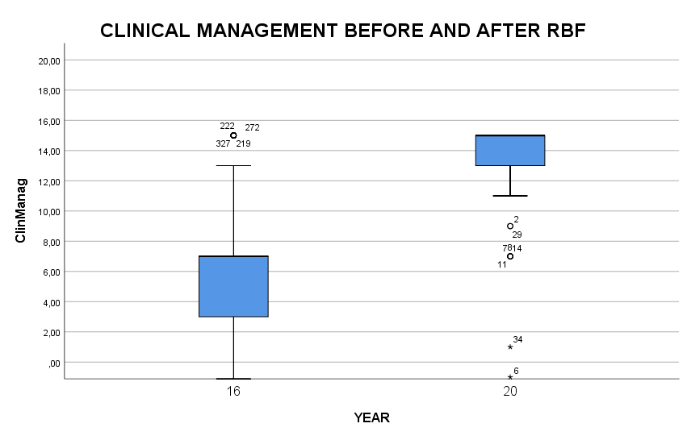

* + - 1. **MULTIVARIATE ANALYSIS**

**Selection of the best items who contribute to improvement from 2016 to 2020**

Since most of the observed items are correlated between themselves, we may offer an overenthusiastic view of the achieved results. For this reason a multivariate analysis is required in order to find which variable more efficiently differentiates the management of patients between year 2016 (before RBF) and year 2020 (three years later).

A stepwise Canonical Discriminant analysis model was fitted to the data, to select the best items able to discriminate between the two years. Wilk’s Lambda estimates the capacity of each variable to differentiate the two years, where 1 = complete overlap and 0 = complete distance.

**Table 4: Items selected to discriminate between year 2016 and year 2020 in Kalongo**

|  |  |  |  |  |
| --- | --- | --- | --- | --- |
| **Step** | **Items** | **Wilk’s lambda** |  | |
| **Anova F** | **p** |
| 1 | Symptom | ,407 | 384,119 | ,000 |
| 2 | Treatm | ,382 | 212,335 | ,000 |
| 3 | Exam | ,369 | 149,217 | ,000 |
| We can observe that the symptoms based on clinical history, the appropriate treatment and the clinical examination are the best discriminators: no other variable contributes significantly to the model.  If we apply the discriminant score obtained by this analysis we could blindly predict, for all the dates, each clinical record’ year,. The Discriminant Model fits adequately the observed data and allows predict correctly to which year the record belongs in 90% of cases. | | | | | |

The correct prediction of 90% of cases in the year they belong provides a robust estimate of the adequacy of the model. The practical indication is that that these 3 items should be reinforced in order to improve the quality of the service.

* + 1. **CLINICAL MANAGEMENT ST. MARY’S HOSPITAL LACOR**

The number of clinical records scrutinized was 162 for the year before RBF (2016) and 111 for the year after RBF 2020

For each score we report the numbers and the % on the total below. A Chi Square is calculated to compare the differences between 2016 and 2020, with first degree error (p) below. How many folds changed from 2016 to 2020 is shown in the last line.

**Table 5 shows the distribution of scores for the required quality item: Clinical Management.**

|  |  |  |  |  |  |  |  |  |  |  |  |  |
| --- | --- | --- | --- | --- | --- | --- | --- | --- | --- | --- | --- | --- |
| **Scores** | **Clinical History** | | **Clinical examination** | | **Malaria managed** | | **Weigth checked** | | **Anemia diagnosed** | | **Sepsis specific diagnosis** | |
|  | **2016** | **2020** | **2016** | **2020** | **2016** | **2020** | **2016** | **2020** | **2016** | **2020** | **2016** | **2020** |
| -1 | 32 | 0 | 29 | 0 | 7 | 0 | 72 | 11 | 2 | 0 | 39 | 10 |
|  | 19,9 | 0,0 | 18,2 | 0,0 | 6,6 | 0,0 | 44,7 | 9,9 | 2,0 | 0,0 | 70,9 | 37,0 |
| 1 | 38 | 5 | 36 | 2 | 2 | 0 |  |  | 1 | 6 | 6 | 6 |
|  | 23,6 | 4,5 | 22,6 | 1,8 | 1,9 | 0,0 | 0,0 | 0,0 | 1,0 | 6,4 | 10,9 | 22,2 |
| 3 | 91 | 106 | 94 | 109 | 97 | 85 | 89 | 100 | 99 | 88 | 10 | 11 |
|  | **56,5** | **95, 5** | **59,1** | **98,2** | **91,5** | **100,0** | **55,3** | **90,1** | **97,1** | **93,6** | **18,2** | **40,7** |
| TOTAL | 161 | 111 | 159 | 111 | 106 | 85 | 161 | 111 | 102 | 94 | 55 | 27 |
|  |  |  |  |  |  |  |  |  |  |  |  |  |
| χ2 | 51 |  | 53,6 |  | 7,57 |  | 37,6 |  | 5,36 |  | 8,66 |  |
| p | 0,00001 |  | 0,00001 |  | 0,023 |  | 0,0001 |  | 5,36 |  | 0,013 |  |
| Fold Changes |  | 1,69 |  | 1,66 |  | 1,09 |  | 1,63 |  | 0,96 |  | 2,24 |

**Table 6 shows the distribution of scores for the required quality items: Treatment**

|  |  |  |  |  |  |  |  |  |
| --- | --- | --- | --- | --- | --- | --- | --- | --- |
| **Scores** | **Treatment proper** | | **Antibiotics required** | | **URTI appropriate** | | **LRTI appropriate** | |
|  | **2016** | **2020** | **2016** | **2020** | **2016** | **2020** | **2016** | **2020** |
| -1 | 35 | 5 | 52 | 10 | 1 | 0 | 0 | 2 |
|  | 21,9 | 4,5 | 33,8 | 9,1 | 14,3 | 0,0 | 0,0 | 7,7 |
| 1 | 14 | 15 | 7 | 18 | 0 | 1 | 10 | 11 |
|  | 8,8 | 13,5 | 4,5 | 16,4 | 0,0 | 20,0 | 50,0 | 42,3 |
| 3 | 111 | 91 | 95 | 82 | 6 | 4 | 10 | 13 |
|  | **69,4** | **82,0** | **61,7** | **74,5** | **85,7** | **80,0** | **50,0** | **50,0** |
| Total | 160 | 111 | 154 | 110 | 7 | 5 | 20 | 26 |
|  |  |  |  |  |  |  |  |  |
| χ2 | 16,18 |  | 27,6 |  | 2,12 |  | 1,68 |  |
| p | 0,0001 |  | 0,0001 |  | 0,34 |  | 0,194 |  |
| Fold Changes |  | 1,18 |  | 1,21 |  | 0,93 |  | 1,00 |

* + - 1. **Fig. 1: Shows the % maximum scores (=3) reached in the year 2016 (first bar) and year 2020 (second bar).**

**Fig. 2 shows the Mean and Interquartile Range of the sum of scores: History + Examination + Weight + Treatment + Antibiotics before and after RBF at Lacor**

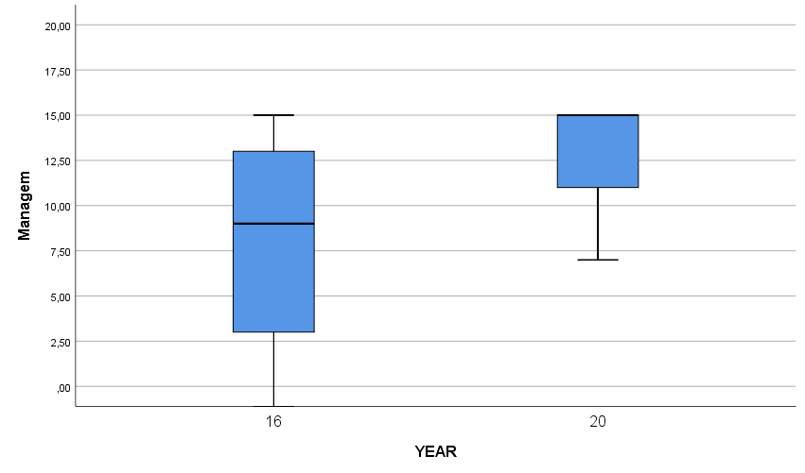

* + - 1. **MULTIVARIATE ANALYSIS**

**Selection of the best items who contribute to improvement from 2016 to 2020**

Since most of the observed analysis are correlated among themselves, a multivariate analysis was required in order to find which variable more efficiently differentiate the management of patients between year 2016 and year 2020.

A stepwise Canonical Discriminant analysis model was fitted to the data, to select the best variables able to discriminate between the two years. Wilk’s Lambda estimates the capacity of each variable to differentiate between the two years, where 1 = complete overlap and 0 = complete distance.

**Table 7 : Items selected to discriminate between year 2016 and year 2020 Lacor**

|  |  |
| --- | --- |
| Step | Item |
| Wilks Lambda |
| F ANOVA | p |
| 1 | Symptom | ,816 | 58,451 | ,000 |
| 2 | Weigth | ,731 | 47,521 | ,000 |
| 3 | Exam | ,711 | 34,865 | ,000 |

We can observe that the symptoms based on clinical history, the measuring of weight and the clinical examination are the best discriminators: no other variable contributes significantly to the model. The acceptable correct prediction of 75% of cases in the year they belong provides a sufficiently robust estimate of the adequacy of the model. The practical indication is that these 3 items should be reinforced in order to improve the quality of the service.

* 1. **PRELIMINARY OBSERVATIONS**

LIMITATIONS:

The blind evaluation of clinical notes, far from the place of the service, on one side reduces any interfering bias but, on the other side, does limit the interpretation of the unclear scripts by very busy doctors.

The provisional report has to be completely revised by the doctors presently on service

The item ‘test required necessary/un-necessary’ is not due to medical choice but, more often, by the availability of the service. We presume that, especially in Kalongo, many test are actually done (for ex. XRay) but are not reported in the clinical notes. For this reason, this item was excluded from the analysis.

For the Neonates Kalongo did not include the forms, which are apparently in a different ward archive. For Lacor a specific analysis is required.

* 1. **CRITICAL POINTS:**

Unfortunately, the weight of the child is not reported in all cases, inasmuch there is no space on the forms to report the weight centile, which is essential to estimate the health of the child. Screening for malnutrition is very occasional and a specific query is not present on the clinical record. The main reason for this is that the assessment is done in the outpatient department, but is not often reported in the clinical record.

Similarly, the immunization status of the child is erratical, since there is no specific query marked on the forms .

The diagnosis of ‘Sepsis’ is applied extensively, without the appropriate search for a cause of the infection. A specific diagnosis would be much encouraged by availability of a simple marker of infection, like the C Reactive Protein (CRP).

* 1. **ACHIEVED RESULTS**

Clinical management of the sick child has been very significantly improved from 2016 (before RBF) to 2020 (after RBF) both in Lacor, where the average level of care was already at a good standard, but more evidently in Kalongo, where the scarcity of human resources limited the quality of care in the years 2014-2016.

It is sufficient to see the fold changes from 2016 to 2020 (% max score achieved in 2020 / % max score achieved in 2016) to estimate the dramatic changes observed at Kalongo (Tables 2 and 3).

The reporting of a detailed clinical history and the accurate examination of the child improved more than 6 times (=600%!). Similarly, good management of sepsis increased 9 times. The appropriateness of the treatment and use of antibiotics improved much less (1,6 - 1,7 times) because it was already often appropriate in 2016.

At Lacor the improvements from 2016 to 2020 appeared less impressive for a good reason: they were starting from a decent quality of care. But the improvement was very significant indeed when considering clinical management and treatment of the sick child.

* 1. **SUGGESTIONS**

A simple and unexpensive action should be taken to improve the quality of clinical records in order to stimulate doctors and nurses to pay a greater attention to items that are often missing:

The daily report should have adequate space

The number of previous admissions should be reported (children who appear to require special care)

Appropriate recording of daily weight

Assessment of the growth percentiles (at least weight, length, arm circumference) at the time of admission.

Every attempt should be made to verify the immunization status

International nomenclature of diseases should be used to report first, second and third diagnosis

In case of a child suspect for malnutrition, a small space to report the actual feeding is needed.

For the many ‘infected’ children with possible ‘Sepsis’ the availability of CPR assay (C reactive Protein) would significantly support a more specific diagnosis

1. **EVALUATION OF THE MANAGEMENT OF NON-COMMUNICABLE ‘SPECIAL’ CASES**

Screening of the Medical Records in the Children’s Wards of the two hospitals allowed a thorough comparison of the clinical management before the RBF project (2016) and the end of the project (2020). Each record was scrupulously examined using a pre-determined form in order to collect comparable data. We obtained a realistic picture of the average management of sick babies in these wards. Robust statistics allowed to estimate the significant changes which occurred over the project’s three years. Nevertheless, tables and graphs do describe the complexity of clinical management, but do not allow to explore management of the single individual. The large number of clinical records examined were, as expected, largely biased toward common communicable diseases, although some stratification for the ten diagnosis proposed in the project was applied.

In order to understand the procedures, the actions and the limitations of the management of the sick child in each hospital, we selected **kidney disorders,** a non-communicable disease ofsufficient complexity to allow monitoring the capacity of dealing with unusual and severe diseases. We scrutinized the Records of 2020, at the end of the project, to estimate the actual level of manpower performance and general management of these conditions.

We analysed 10 cases of children with a diagnosis of ***nephritis or nephrotic syndrome*** in each of the two hospitals, Kalongo and Lacor.

The age range of these children was 2-12 years, and the hospital stay was 5 to 11 days. Clinical features were accurately reported in all cases upon admission (puffiness, oedema, general status, abdomen, ascites). Unfortunately daily weight was not recorded in all cases. Pulse, heart, respiratory rates were recorded, as well as blood pressure repeatedly. Fluid intake and output was estimated in 100% of cases, despite the expected difficulties of collecting urine in small children.

Urine analysis was available in multiple occasions during the hospital stay, and serum electrolytes together with BUN were analysed both in Kalongo and in Lacor. Treatment included reduction of salt intake, use of diuretics (Lasix and Nifedipine), Prednisone as indicated for nephrotic syndrome as well as Captopril. Glomerular Filtration rate was often reported in kalongo’s records. Antibiotics were prescribed in the usual Ampicillin-Gentamicin association to all cases except for one case in Lacor. Other antibiotics, suchas Nitrofurantoin, Ciprofloxacin, Ceftriaxone, were also administered (more often at Kalongo, compared to Lacor). Two cases in Kalongo were protected with Omeprazole. Appropriate treatment with Artesunate was given in case of Malaria.

In conclusion, management of these complex non-communicable diseases cases was carried out according to international standards. Both diagnosis and treatment followed the most appropriate guidelines for the respective diseases.

Unfortunately, the future outcome (prognosis) of many children affected by nephrotic syndrome could be seriously limited by the lack of causal classification of their disease, which requires, in most cases, kidney needle biopsy histological assessment, which should be organized with a specific referral system in the country.

1. **NEONATES AT LACOR HOSPITAL**

Cases selected by Age <= 1 month (neonatal age)

|  |  |  |  |  |
| --- | --- | --- | --- | --- |
|  | | YEAR | | Total |
| 2016 | 2020 |
| Diagnosis | URTI | 1 | 0 | 1 |
| Sepsis | 19 | 11 | 30 |
| Pyloric stenosis | 0 | 1 | 1 |
| Pneumonia | 1 | 0 | 1 |
| Meningitis | 1 | 0 | 1 |
| Megacolon | 0 | 1 | 1 |
| Icterus | 0 | 2 | 2 |
| Diarrhea | 1 | 0 | 1 |
| CHD | 0 | 2 | 2 |
| Asphyxia | 0 | 6 | 6 |
| Anemia | 1 | 0 | 1 |
| Total | | 24 | 23 | 47 |

Average score of ‘Management’(=History + Examination + Weight + Treatment + Antibiotics) of Neonatal Cases in 2016: 6,6 versus in 2020: 12,5 Student t-test = 4,55 p = 0,0001 : The score improved by 100%.

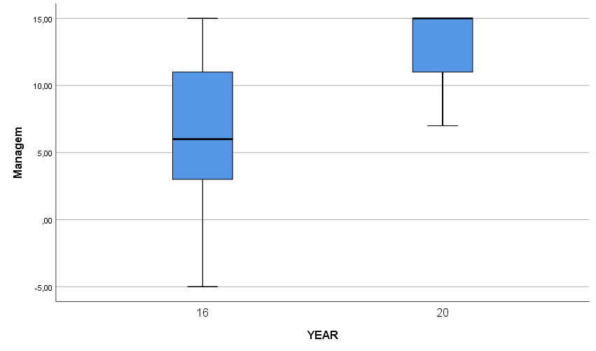

COMMENTS

A very significant improvement was observed before/after the RBF project for the care of neonates.

The unspecific diagnosis of ‘Sepsis’ decreased from 79% in 2016 to 46% in 2020. At the same time, the complexity and specificity of diagnosis was significantly more frequent in 2020 compared to 2016. **A Clinical record dedicated to the Neonates could significantly help simplifying and improving the service**.

REPORT OF THE QUALITY ASSESSMENT OF NURSING PROCEDURES

27/05/2021

St.Mary’s Hospital Lacor – Ambrosoli Hospital Kalongo

Valentina Mozzi & Team of Nurses

St. Marys’ Hospital Lacor – Dr.Ambrosoli Kalongo Hospital –

Results Based Financing Program 2018-2021

**OBJECTIVE:** To evaluate any possible improvement in the nursing procedures from the year 2016 (before the RBF project) to the year 2020 (at the end of the RBF project) in the hospital participating to the project (St.Mary’s Hospital Lacor and Ambrosoli Hospital, Kalongo).

METHODS: A nursing procedure review form was developed before the start of the project, by the nursing cadres of both hospital, under the supervision of an independent nursing expert (VM).

NURSING PROCEDURES REVIEW FORM

CASE ID __________ Admitted |__|__|____| Discharged |__|__|____| Age mo|_____|

DIAGNOSIS:_______________________________________________________________

|  |  |
| --- | --- |
| **Proper administration of therapies of 10 x 8 admitted cases** |  |
|  |  |
| 1) Therapies have been given properly (Oral, injection, IV line, fluids) | **N.A. 0□ NO -1□ Unclear 1□ YES 3□** |
| **2)** Charts correspond to the correct patients | **N.A. 0□ NO -1□ Unclear 1□ YES 3□** |
| **3**) Weight and vital signs recorded (Wt, Temp, Resp Rate etc) | **N.A. 0□ NO -1□ Unclear 1□ YES 3□** |
| **4)** Fluids balance chart is present, when applicable | **N.A. 0□ NO -1□ Unclear 1□ YES 3□** |
| **5)** Bowel actions recorded in case of diarrhea - dehydration | **N.A. 0□ NO -1□ Unclear 1□ YES 3□** |
| **TOTAL SCORE** |  |

The enquires were run during the spring season in both hospitals, by the independent nursing expert.

Data, transferred on appropriate data base, were then analyzed blindly (by year) by the data analysis team of the RBF project. (L.G and M.A., University of Naples, Italy).

**RESULTS**

N. of Clinical Records evaluated

|  |  |  |  |  |
| --- | --- | --- | --- | --- |
|  | | Hosp | | Total |
| Lacor | Kalongo |
| YEAR | 2016 | 220 | 123 | 343 |
| 2020 | 46 | 163 | 209 |
| Total | | 266 | 286 | 552 |

MEAN TOTAL SCORE OF NURSING CARE IN BOTH HOSPITALS

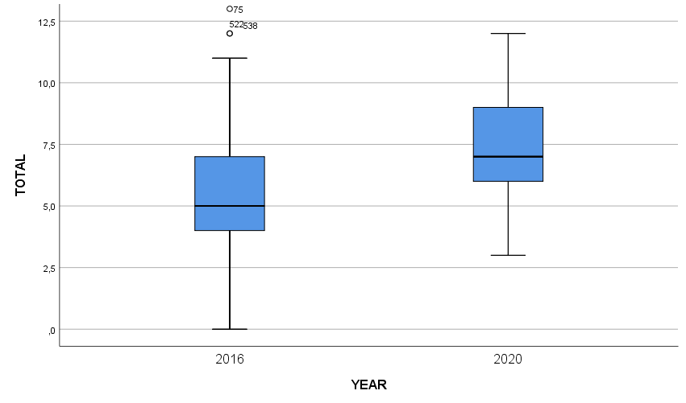

The mean total score was obtained summing the scores of the nursing record for each year.

**Q1- Therapies have been given properly (Oral, injection, remove IV line, fluids)**

Metodological note: we didn’t consider fluids administration because enquired in another point.

|  |  |
| --- | --- |
| NA | When no sheet available |
| NO | When no sign for at least one day and 50% less is documented |
| Unclear | When the administration of 50% of medications are not clear  When treatment is written in the obs chart and not clearly signed  When some antibiotics’ doses are missed |
| YES | When >80% of the administration is correctly documented |

|  |  |  |  |  |
| --- | --- | --- | --- | --- |
|  | **Therapy Given Properly** | | | |
|  | **LACOR** | | **KALONGO** | |
|  | **2016** | **2020** | **2016** | **2020** |
| Inadequate | 16 (7,5%) | 0 (0,0%) | 3 *(2,4%)* | 4 *(2,5%)* |
| Uncertain | 89 (41,6%) | 9 (19,6%) | 73 *(59,3%)* | 47 *(28,8%)* |
| Perfect | 109 (50,9%) | 37 (80,4%) | 47 *(38,2%)* | 112 *(68,7%)* |
| Total | 214 | 46 | 123 | 163 |
|  | Chi Sq **14 p = 0,001** | | Chi Sq **27 p < 0,0001** | |

**Q2- Charts correspond to the correct patients**

Metodological note: If the administration sheet is in another patient’s file, we decided to assess the chart anyway for what concern the other scores. In Kalongo 2014, patients' files were made only by two sheets stapled together.

In Lacor 2016, patient’s treatment chart never reports the patient’s name because there was no specific space on the sheet where to write it; it was written only in the obs chart or other forms, so we decided to check identity of the patients toward progress notes or other forms.

|  |  |
| --- | --- |
| NA | When no sheet available |
| NO | When the chart has another patient’s name |
| Unclear | When the name on the chart is not completely readable  When the name of the patient is written only in one sheet |
| YES | When correct |

|  |  |  |  |  |
| --- | --- | --- | --- | --- |
|  | **Charts to patient** | | | |
|  | **LACOR** | | **KALONGO** | |
|  | **2016** | **2020** | **2016** | **2020** |
| Inadequate | 10 (4,5%) | 1 (2,2%) |  |  |
| Uncertain | 28 (12,7%) | 2 (4,3%) | 59 *(48,0%)* | 2 *(1,2%)* |
| Perfect | 182 (82,7%) | 43 (93,5%) | 64 *(52,0%)* | 161 *(98,8%)* |
| Total | 220 | 46 | 123 | 163 |
|  | Chi Sq **3 p >0,1** | | Chi Sq **91 p < 0,00001** | |

**Q3- Weight and vital signs recorded (Wt, Temp, Resp Rate etc)**

|  |  |
| --- | --- |
| NA | When no sheet available |
| NO | When no weight or no sign recorded |
| Unclear | When weight or at least one sign is monitored |
| YES | When weight or observations are regularly monitored |

|  |  |  |  |  |
| --- | --- | --- | --- | --- |
|  | **WT and Vital reported** | | | |
|  | **LACOR** | | **KALONGO** | |
|  | **2016** | **2020** | **2016** | **2020** |
| Inadequate | 72 (34,6%) | 0 (0,0%) | 2 (1,6%) | 7 (4,3%) |
| Not Available |  |  | 0 (0,0%) | 1 (0,6%) |
| Uncertain | 108 (51,9%) | 34 (73,9%) | 27 (22,0%) | 98 (60,1%) |
| Perfect | 28 (13,5%) | 12 (26,1%) | 94 (76,4%) | 57 (35,0%) |
| Total | 208 | 46 | 123 | 163 |
|  | Chi Sq **23 p = 0,0001** | | Chi Sq **48 p < 0,0001** | |

In Kalongo most of the children are regularly weighted and temperature is frequently checked in both years.

In Lacor, children were sometimes weighted in 2016, but in 2020 they were regularly weighted and observations sometimes recorded.

**Q4- Fluids balance chart is present, when applicable**

Metodological note: we did not assess the prescription of oral rehydration solution (ORS) because it is demanded to mothers or attendants to administer it to the children. We considered prescription of IV fluids and consequent administration by the nurses; we also considered and assessed blood transfusion when the given amount in mls was recorded.

|  |  |
| --- | --- |
| NA | no fluids prescription in place |
| NO | when the prescription is in place and no administration is recorded |
| Unclear | when the prescription is in place and partial administration is recorded (e.g. recorded partially in treatment sheet or when at least blood transfused amount is recorded) |
| YES | when the prescription is in place and administration is recorded |

|  |  |  |  |  |
| --- | --- | --- | --- | --- |
|  | **Fluid balance** | | | |
|  | **LACOR** | | **KALONGO** | |
|  | **2016** | **2020** | **2016** | **2020** |
| Inadequate | 13 (43,3%) | 1 (10,0%) | 10 (47,6%) | 16 (25,0%) |
| Uncertain | 9 (30,0%) | 2 (20,0%) | 7 (33,3%) | 26 (40,6%) |
| Perfect | 8 (26,7%) | 7 (70,0%) | 4 (19,0%) | 22 (34,4%) |
| Total | 30 | 10 | 21 | 64 |
|  | Chi Sq **6,4 p = 0,041** | | Chi Sq **4 p = 0,1** | |

In Kalongo fluids are prescribed in the treatment sheet and nurses sign for it. There isn’t no fluid sheet in use, we assessed if they were infused according to the observation chart or treatment chart.

In Lacor a specific fluids sheet has been introduced and nowadays it is regularly used by doctors to prescribe IV fluids and by nurses to document starting time, rate and amount of drip given.

**Q5- Bowel actions recorded in case of diarrhea – dehydration**

|  |  |
| --- | --- |
| NA | Diagnosis different then diarrhea-dehydr |
| NO | Diagnosis is diarrhea-dehydr and no bowel occurrence has been recorded |
| Unclear | Diagnosis is diarrhea-dehydr and at least one bowel occurrence has been recorded |
| YES | Diagnosis is diarrhea-dehydr and two or more bowel occurrence has been recorded |

|  |  |  |  |  |
| --- | --- | --- | --- | --- |
|  | **Bowel recorded** | | | |
|  | **LACOR** | | **KALONGO** | |
|  | **2016** | **2020** | **2016** | **2020** |
| Inadequate | 22 (64,7%) | 0 (0,0%) | 26 (96,3%) | 10 (90,9%) |
| Uncertain | 6 (17,6%) | 0 (0,0%) | 1 (3,7%) | 1 (9,1%) |
| Perfect | 6 (17,6%) | 2 (100,0%) |  |  |
| Total | 34 | 2 | 27 | 11 |
|  | Chi Sq **7,4 p = 0,025** | | Chi Sq **0,4 p >0,5** | |

Both in Lacor and in Kalongo scores are very low even in 2020, because nurses are not used to record bowel action on the chart; it is usually up to doctors to record them in the progress note during ward round.

**TOTAL SCORE KALONGO TOTAL SCORE LACOR**

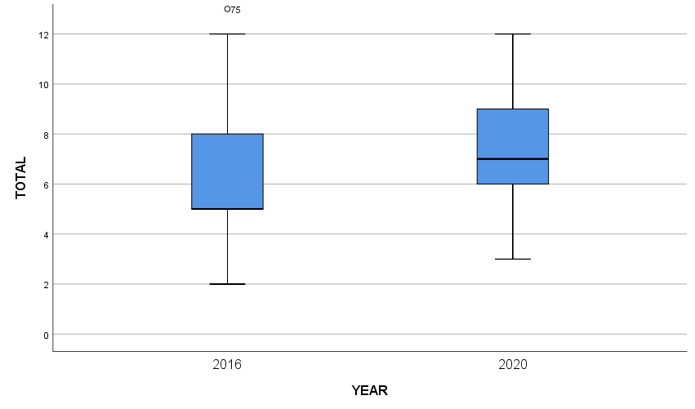

**FINAL COMMENTS ON NURSING INDICATORS**

The indicators presented in this report were chosen during the planning phase of the study in order to represent some specific areas of nursing intervention of which nurses are responsible for.

Looking at the box plot, it appears clearly a general improvement of the scores assigned for both hospitals under study. The average score increases in 2020 demonstrating a general improvement for what concerns the clarity and the completeness of the documentation. Also, the files with very low scores decreased and the minimum values ​​ are higher in 2020.

Looking at treatment charts’ indicator, for what concerns the correct documentation of administrations, Lacor’s percentages start from 50.9% in 2016 and go up to 80.4% in 2020; Kalongo’s ones also recorded a good improvement, passing from 38.2% to 68.7% in 2020; in both hospitals the statistical tests are significant, meaning that an improvement in the observed data is not due to randomness.

Another important indicator that also present statistically significant results is the one that investigate the completeness of documentation of vitals observations. Due to the methodology adopted in assigning the scores, for what concerns the category “Unclear” we register a considerable increase indeed; percentages go from 51.9% in 2016 to 73.9% at Lacor and, in Kalongo they go from 22.0% in 2016 to 60.1% in 2020. Apparently these results might look negative, as both hospitals have rather low percentages in the "Perfect" category, and especially in Kalongo in 2020 the “Unclear” actually increases if compared to the “Perfect”. The explanation for that is related to the severe methodology adopted; compared to Western standards, in which all the patients' vitals are regularly checked even if not out of range, the choice of assigning “Unclear” when weight and at least one vital sign is monitored, has penalized the results.

There are also some important considerations related to the context that must be taken into account to have a clear representation of the results:

The acuity and complexity of diseases, the large number of patients and the intense workload can makes it difficult to accurately record data; this doesn’t mean that the patient are not monitored and regularly checked.

Another important consideration is related to medical records management: in Lacor, treatment sheet always remains at the patient's bedside, while the complete folder, including observation chart, is usually kept somewhere else and consulted mainly during the ward round; this makes registration of observations a time-consuming activity for nurses, because the chart is not immediately available when a specific vital parameter is checked.

Regarding missing doses for some treatments, it must be considered that children and mothers are not always at their bedspace; nurses are used to call them with a bell that announces medications round, but sometimes they don’t show up, compromising the correct administration.

In conclusion, the study is able to intercept a global improvement in document completeness even if there are still some areas of improvement; in our opinion, these are mainly related to the high complexity of the context under study.

**GENERAL COMMENTS BY HOSPITAL DIRECTOR Dr. Smart**

AMBROSOLI HOSPITAL, KALONGO

The RBF project funded by AICS and implemented in Kalongo hospital from April 2018 to March 2021 was the second RBF project implemented in DAMH, after a long pause following the conclusion of NU HEALTH project in in 2015.

The project indicators and verification assessment focussed on qualitative and quantitative outputs of paediatric services, involving children ward and other hospital services necessary for diagnostic support to the children ward, such as radiology and laboratory.

The first project verification obtained a score of 62% and highlighted several weaknesses, regarding a range of aspects such as infrastructure, ward organisation, waste management, incomplete clinical forms and fluid balance charts. During the first staff follow-up meeting to discuss the verification results, the quality team and children ward staff engaged very proactively in the identification of a clear action plan, setting out individual responsibilities and deadlines for each point to be addressed. Some of the non-compliances highlighted in the first verification that regarded purchase of equipment were addressed immediately by staff and management, such as setting up of more hand-washing facilities and hypochlorite, purchase of waste bins and sterilisation unit. The non-compliances that regarded broader aspects such as management of clinical forms and other aspects related to clinical and nursing processes required a lengthier process for improvement, but at mid project such improvements have started to be visible in the quarterly verifications and the results show an improvement in all areas subject to verification, exception made for aspects that an RBF project cannot solve such as the difficulty in retaining specialists in rural and underserved health facilities.

Throughout the project implementation, staff has kept proactive in carrying out post assessment follow up meetings, with clear identification of responsibilities and deadlines. Documentation of follow-up meetings to record progress made in addressing non-compliances is however weak and should be a point of attention for future RBF projects.

The bonus produced as a result of the verification scores has been used by the hospital both for assigning incentives to staff involved in the project activities, and for supporting general hospital costs, with priority for costs related to addressing any weaknesses identified during the verifications. The division between these 2 components was for the first year 40% to staff incentives and 60% to support of general hospital expenses, with particular focus on improvement of paediatric services. This division was then modified to 35% staff incentives and 65% hospital expenses starting from the 4th quarter of the 1st year.

During the first project year, hospital management decided to accumulate staff bonus and pay it in one shot on a yearly basis, rather than distribute it immediately, in order to award a larger sum to staff involved in the verifications and give a higher perception of the bonus, which would be a much smaller sum if distributed quarterly. This decision however created some confusion in staff, who did not have a clear perception of the timeframe of bonus reception and of the amount that they expected to receive, thus lacking a clear view of the impact of their individual performance on the financial outcome of the project. The first bonus payment was distributed in April 2019, one year after project initiation. There was not a strict correlation between payments of staff incentives and improvements of staff performance. The verification held on January 24th 2019 obtained for the first time score 4 ( verification results 84%), marking a strong improvement from the 2 previous verifications which both achieved score 2 (63 and 66%). This improvement occurred before for first payment of incentives to staff, and surprisingly during the following verification, which occurred after staff incentive payment, the results dropped back to score 2. Also during the 2nd project year payments of staff incentive continued to be accumulated rather than paid quarterly. The scores kept between 68% and 74%, until the surge in quality performance that was recording during the verification held on February 6th 2020, which again occurred shortly before the payment of staff incentive which was carried out on February 18th. It is possible that the expectation of receiving staff incentive shortly after the verification boosted staff performance, however the evidence for this claim is weak, since the surge in quality performance was maintained constantly during the 5 following verifications, which scored an average of 90% (score 5).

In 2020 management decided to issue more frequently payments of staff incentives (February 2020, June 2020, December 2020), to give staff a clearer perspective of the impact of their performance on the amount received as incentive. In addition to frequency of payment, the most significant change for the 3rd project year was the decision of management to distribute bonus to staff according to individual performance, rather than equal distribution regardless of individual performance, as done during the bonus payments for 1st and 2nd project year, where all staff of children ward and neonatal unit received a lump sum equal across positions (medical officer receiving the same as nursing assistant), and staff of other hospital units strictly related to children ward health service delivery (laboratory, radiology, pharmacy, etc.) received a lower lump sum, also in this case equal for all positions.

The payment of staff incentives carried out in December 2020, which covered payment of incentives for the 1st semester of 3rd year, for the first time introduced an evaluation of staff performance, carried out by the medical director and CEO. The basic distinction between first category (staff in children ward) and second category (staff of other hospital units) was maintained, however staff in 1st category who had underperformed was placed in 2nd category for the bonus distribution, and *viceversa* for staff in 2nd category who had demonstrated a particular work commitment. The payment of staff incentives for the 2 final quarters of the 3rd year will be carried out on a quarterly basis, to have a clearer picture of the impact of the introduction of merit criteria for the distribution of staff incentives.